Disclaimer: The author of the article is a creator of the Social Buzz tool and it shouldn’t be considered as a promotional post .

# TOP 8 Free Social Media Search Engines Compared and Tested.

What's being said about you or your company? Who are the most influential fans of your product? Social networks audit is one of the daily routine activities for many people and it can be simplified by using real-time social search engines that combine information from various sources in one place.

In order to be objective as much as possible, we‘ll focus on the functions of the social searching tools and their testing. User interface experience and performance questions are postponed for your personal examination.

Let’s have a look on the pros and cons of the most mentioned social media search engines on the web:

## Social Buzz

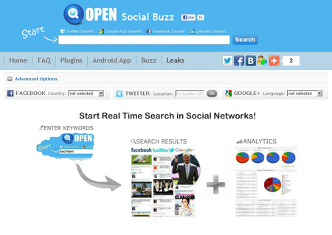

[Social Buzz](http://www.social-searcher.com/social-buzz/) is a real time search engine for Facebook, Twitter and Google+, which was recently launched by the [Social Searcher](http://www.social-searcher.com) company.

The new service supports Facebook, Twitter and Google+ social networks for searching with the possibility to exclude unneed ones. You can use multiple keywords, exact keywords and minus keywords to filter out desired content. Additional search results filters are as follows: content type (videos, images, links, statuses) and popularity (likes, retweets, plus ones and reshares).

Social Buzz provides a quick possibility to change your search locale: country for the Facebook, location for the Twitter and language for the Google+. Different languages are supported for the keywords searching and displaying in the search results. You can load older posts for Twitter and Google+ by clicking on the "More results" link.

Low internet connection users also have helpful options: embeding of the videos and images in the search results can be disabled.

Social Buzz provides deep search results analytics for the marketers: posts types, top links/domains, keywords, sentiment, top users and posts. In case of long term studies it's not very helpful, cause the search results contain only recent history. If your company doesn't have a budget for the professional web monitoring tools or you want to make a quick check of your brand in the social networks, than Social Buzz might be an option.

Finally, you can install browser search plugin for the quick access to the tool.

## SocialMention

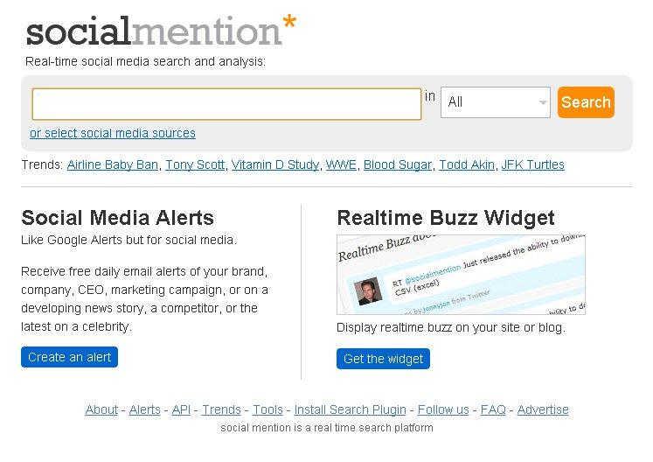

[Social Mention](http://socialmention.com) is a social media search and analysis platform, which declares to use 100+ sources. You can select only needed ones, but, actually, it’s hard to find popular social networks like Facebook or Twitter (Google+ is not supported) in the sources list if you want to narrow down the search results:

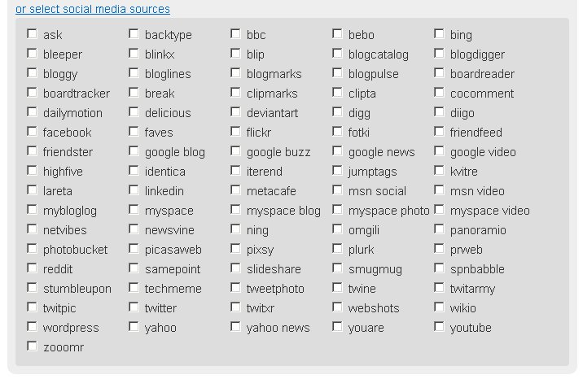  
After selecting the target networks you can get the search results, but changing of the keyword and next searching on the search results page will end up with the ALL sources search.

SocialMention allows you to search exact phrase or use minus words. Also it provides search results analytics with the data export to CSV: last and avg mention time, sentiment, keywords, top users and hashtags.

There are some additional nice features: Email Alerts, Realtime Buzz Widget and browser search plugin.

It is surprising that SocialMention has a number of tabs like Comments, Networks and Audio that always produce empty search results even for the popular keywords. Video tab always hangs while searching and after a few minutes of waiting you'll give up.

The service declares support of languages via Preferences, but, for example, testing with the Russian language fails: always empty results with and without Russian language selected.

Also there is a bug, which appears sometimes in the results:

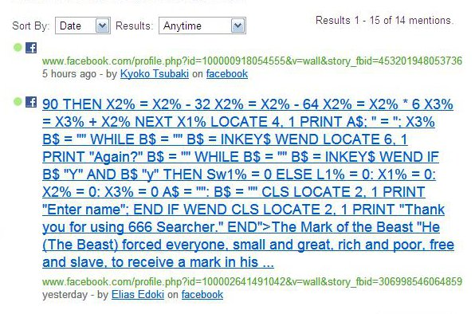

Social Mention utilizes impressive number of the social sources and search results analytics can give you some general information about your brand mentions in the social media. At the same time, it may be time consuming if you want to analyze only particular social networks with the tool.

## Topsy

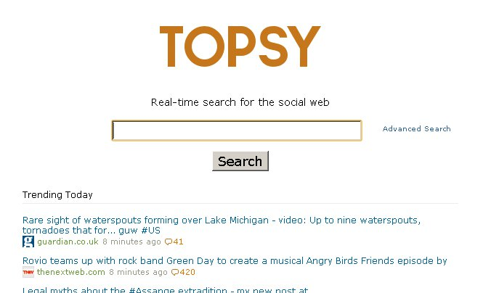

[Topsy](http://topsy.com) is a part of Topsy Labs company, which provides indexing technologies for the massive amounts of the social data.

This tool supports Twitter and Google+(Beta) social networks for searching. It's a very powerful service for analyzing Twitter mentions: Topsy provides deep Tweets history as well as main Twitter influencers with the help of the the own indexing system. Twitter Search API can fetch only 1 week history. Topsy's Google+ Beta also looks promising and we can expect to it to be as useful as the Twitter one. If you are looking for other social networks' search results, than Topsy won't help you at this time.

The tool allows you to use different languages, search exact phrase or apply minus words, for more, search results can be filtered by content type (videos, images, links and statuses).

Another useful features are as follows: Email Alerts and Social Modules for your website.

Free Analytics compare tool, provided by the service, is worth having a look, but for more historical data, sentiment, geography and other stats you'll have to pay for a Pro membership.

## Kurrently

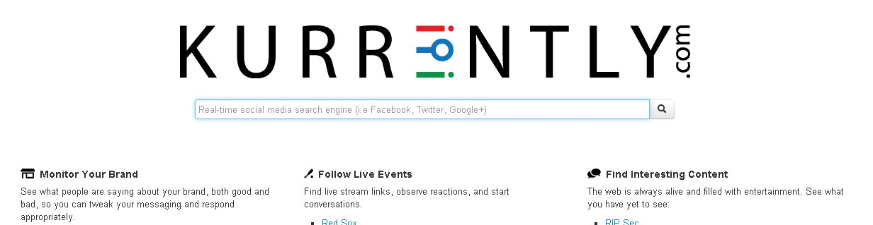

[Kurrently](http://www.kurrently.com/) is a real-time social media search engine for Twitter and Facebook. Google+ is also declared to be supported, but actually we couldn’t get any search results.

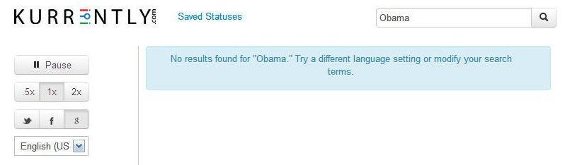

The tool supports different languages for searching and displaying in the search results.

Kurrently refreshes search results automatically and while searching for some rare keywords it adds duplicate entries one by one.

If you want to lean back on the chair and meditate while looking at the fetching of the new posts from the Twitter and Facebook, than Kurrently is the right choise.

## Whostalking



[WhosTalkin](http://whostalkin.com/) is a social media search tool that allows users to search for conversations surrounding the topics that they care about most. It supports a lot of sources for searching, but without possibility of the multiple select. Also some social sources seem to be out of work and provide empty results even for the popular keywords, may be the service is not updated anymore, cause the last blog post was in 2010.

This tool doesn't support different languages for searching and has only one additional feature: browser search plugin.

WhosTalkin's site has a good web ranking, so it can be competitive enough if updated appropriately.

## 48ers

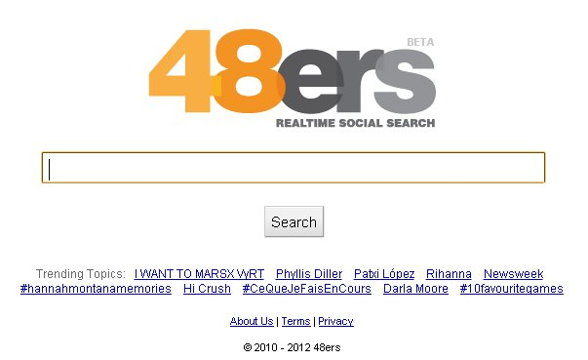

[48ers](http://48ers.com) is created to help you search for what's happening right now using several social sources with the possibility to select only one.

This tool still got Google Buzz in the list, which is out of work. Digg search is not working also.

Trending Topics of the 48ers may overlap with the search results:

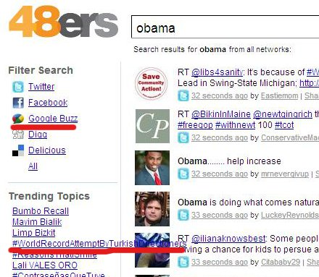

The service supports different languages only when searching from the home page. The same query from the search results page will result for you with the bunch of "hieroglyphs".

## Spy

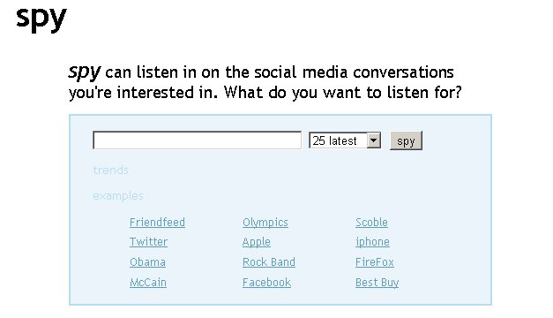

[Spy](http://spy.appspot.com/) declares social media search, but, actually, it utilizes only Twitter search and has no options but for displaying recent results.

By default it adds posts one by one reaaaaly slow, so the only way is to press "Show all".

## SamePoint

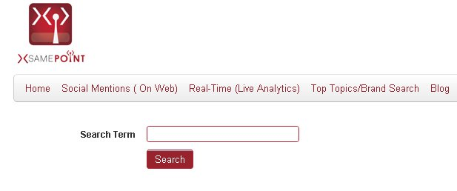

[Samepoint](http://www.samepoint.com) is a social media search platform, which was mentioned a lot on the web, but it seemed to change a lot comparing to the existing reviews.

First of all, now it requires account registration to start searching. Under the tool "Social Mentions (On Web)" the service provides... a list of links, which more look like a parsed search result from google with moved up some social sources (Twitter, Facebook, Youtube etc).

We’ve created a small test, which exposes this fact:

Goggle search result for the “Bomb” with site:facebook.com option is compared with Samepoint.  
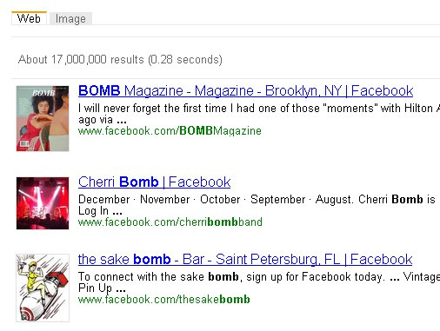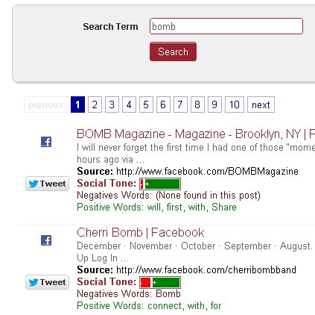

## Bonus

There were some good free social media search engines, which were closed, but worth mentioning in the article due to the big media impact in the past.

It may be surprise for some people that following services are offline now:

[http://youropenbook.org](http://youropenbook.org/) - out of work

<http://surchur.com> - out of work

<http://www.booshaka.com> - now it’s commersial social marketing platform.

­

## Free Social Media Search Engines Compared

|  |  |  |  |  |  |  |
| --- | --- | --- | --- | --- | --- | --- |
|  | Social Buzz | SocialMention | Topsy | Kurrently | Whostalking | 48ers |
| Facebook | D:\ORD\Search_Sites\SocialSearcher\Top8Compared\1345560865_check.png | D:\ORD\Search_Sites\SocialSearcher\Top8Compared\1345560865_check.png | D:\ORD\Search_Sites\SocialSearcher\Top8Compared\1345560970_minus.gif | D:\ORD\Search_Sites\SocialSearcher\Top8Compared\1345560865_check.png | D:\ORD\Search_Sites\SocialSearcher\Top8Compared\1345560865_check.png | D:\ORD\Search_Sites\SocialSearcher\Top8Compared\1345560865_check.png |
| Twitter | D:\ORD\Search_Sites\SocialSearcher\Top8Compared\1345560865_check.png | D:\ORD\Search_Sites\SocialSearcher\Top8Compared\1345560865_check.png | D:\ORD\Search_Sites\SocialSearcher\Top8Compared\1345560865_check.png | D:\ORD\Search_Sites\SocialSearcher\Top8Compared\1345560865_check.png | D:\ORD\Search_Sites\SocialSearcher\Top8Compared\1345560865_check.png | D:\ORD\Search_Sites\SocialSearcher\Top8Compared\1345560865_check.png |
| Google+ | D:\ORD\Search_Sites\SocialSearcher\Top8Compared\1345560865_check.png | D:\ORD\Search_Sites\SocialSearcher\Top8Compared\1345560970_minus.gif | D:\ORD\Search_Sites\SocialSearcher\Top8Compared\1345560865_check.png | D:\ORD\Search_Sites\SocialSearcher\Top8Compared\1345560970_minus.gif | D:\ORD\Search_Sites\SocialSearcher\Top8Compared\1345560970_minus.gif | D:\ORD\Search_Sites\SocialSearcher\Top8Compared\1345560970_minus.gif |
| Other | D:\ORD\Search_Sites\SocialSearcher\Top8Compared\1345560970_minus.gif | 100+ Sources | D:\ORD\Search_Sites\SocialSearcher\Top8Compared\1345560970_minus.gif | D:\ORD\Search_Sites\SocialSearcher\Top8Compared\1345560970_minus.gif | Several Sources | Several Sources |
| Multiple Keywords | D:\ORD\Search_Sites\SocialSearcher\Top8Compared\1345560865_check.png | D:\ORD\Search_Sites\SocialSearcher\Top8Compared\1345560970_minus.gif | D:\ORD\Search_Sites\SocialSearcher\Top8Compared\1345560970_minus.gif | D:\ORD\Search_Sites\SocialSearcher\Top8Compared\1345560970_minus.gif | D:\ORD\Search_Sites\SocialSearcher\Top8Compared\1345560970_minus.gif | D:\ORD\Search_Sites\SocialSearcher\Top8Compared\1345560970_minus.gif |
| Exact Keywords | D:\ORD\Search_Sites\SocialSearcher\Top8Compared\1345560865_check.png | D:\ORD\Search_Sites\SocialSearcher\Top8Compared\1345560865_check.png | D:\ORD\Search_Sites\SocialSearcher\Top8Compared\1345560865_check.png | D:\ORD\Search_Sites\SocialSearcher\Top8Compared\1345560970_minus.gif | D:\ORD\Search_Sites\SocialSearcher\Top8Compared\1345560970_minus.gif | D:\ORD\Search_Sites\SocialSearcher\Top8Compared\1345560970_minus.gif |
| Minus  Keywords | D:\ORD\Search_Sites\SocialSearcher\Top8Compared\1345560865_check.png | D:\ORD\Search_Sites\SocialSearcher\Top8Compared\1345560865_check.png | D:\ORD\Search_Sites\SocialSearcher\Top8Compared\1345560865_check.png | D:\ORD\Search_Sites\SocialSearcher\Top8Compared\1345560970_minus.gif | D:\ORD\Search_Sites\SocialSearcher\Top8Compared\1345560970_minus.gif | D:\ORD\Search_Sites\SocialSearcher\Top8Compared\1345560970_minus.gif |
| Results Analytics | D:\ORD\Search_Sites\SocialSearcher\Top8Compared\1345560865_check.png | D:\ORD\Search_Sites\SocialSearcher\Top8Compared\1345560865_check.png | D:\ORD\Search_Sites\SocialSearcher\Top8Compared\1345560970_minus.gif | D:\ORD\Search_Sites\SocialSearcher\Top8Compared\1345560970_minus.gif | D:\ORD\Search_Sites\SocialSearcher\Top8Compared\1345560970_minus.gif | D:\ORD\Search_Sites\SocialSearcher\Top8Compared\1345560970_minus.gif |
| Languages Support | D:\ORD\Search_Sites\SocialSearcher\Top8Compared\1345560865_check.png | D:\ORD\Search_Sites\SocialSearcher\Top8Compared\1345560970_minus.gif | D:\ORD\Search_Sites\SocialSearcher\Top8Compared\1345560865_check.png | D:\ORD\Search_Sites\SocialSearcher\Top8Compared\1345560865_check.png | D:\ORD\Search_Sites\SocialSearcher\Top8Compared\1345560970_minus.gif | D:\ORD\Search_Sites\SocialSearcher\Top8Compared\1345560865_check.pngD:\ORD\Search_Sites\SocialSearcher\Top8Compared\1345560970_minus.gif |
| Content type Filtering | D:\ORD\Search_Sites\SocialSearcher\Top8Compared\1345560865_check.png | D:\ORD\Search_Sites\SocialSearcher\Top8Compared\1345560970_minus.gif | D:\ORD\Search_Sites\SocialSearcher\Top8Compared\1345560865_check.png | D:\ORD\Search_Sites\SocialSearcher\Top8Compared\1345560970_minus.gif | D:\ORD\Search_Sites\SocialSearcher\Top8Compared\1345560970_minus.gif | D:\ORD\Search_Sites\SocialSearcher\Top8Compared\1345560970_minus.gif |
| Popularity  Filtering | D:\ORD\Search_Sites\SocialSearcher\Top8Compared\1345560865_check.png | D:\ORD\Search_Sites\SocialSearcher\Top8Compared\1345560970_minus.gif | D:\ORD\Search_Sites\SocialSearcher\Top8Compared\1345560970_minus.gif | D:\ORD\Search_Sites\SocialSearcher\Top8Compared\1345560970_minus.gif | D:\ORD\Search_Sites\SocialSearcher\Top8Compared\1345560970_minus.gif | D:\ORD\Search_Sites\SocialSearcher\Top8Compared\1345560970_minus.gif |
| More Results  Loading | D:\ORD\Search_Sites\SocialSearcher\Top8Compared\1345560865_check.png | D:\ORD\Search_Sites\SocialSearcher\Top8Compared\1345560970_minus.gif | D:\ORD\Search_Sites\SocialSearcher\Top8Compared\1345560865_check.png | D:\ORD\Search_Sites\SocialSearcher\Top8Compared\1345560970_minus.gif | D:\ORD\Search_Sites\SocialSearcher\Top8Compared\1345560970_minus.gif | D:\ORD\Search_Sites\SocialSearcher\Top8Compared\1345560970_minus.gif |
| Email Alerts | D:\ORD\Search_Sites\SocialSearcher\Top8Compared\1345560970_minus.gif | D:\ORD\Search_Sites\SocialSearcher\Top8Compared\1345560865_check.png | D:\ORD\Search_Sites\SocialSearcher\Top8Compared\1345560865_check.png | D:\ORD\Search_Sites\SocialSearcher\Top8Compared\1345560970_minus.gif | D:\ORD\Search_Sites\SocialSearcher\Top8Compared\1345560970_minus.gif | D:\ORD\Search_Sites\SocialSearcher\Top8Compared\1345560970_minus.gif |
| Browser Plugin | D:\ORD\Search_Sites\SocialSearcher\Top8Compared\1345560865_check.png | D:\ORD\Search_Sites\SocialSearcher\Top8Compared\1345560865_check.png | D:\ORD\Search_Sites\SocialSearcher\Top8Compared\1345560970_minus.gif | D:\ORD\Search_Sites\SocialSearcher\Top8Compared\1345560970_minus.gif | D:\ORD\Search_Sites\SocialSearcher\Top8Compared\1345560865_check.png | D:\ORD\Search_Sites\SocialSearcher\Top8Compared\1345560970_minus.gif |
| Site Widget | D:\ORD\Search_Sites\SocialSearcher\Top8Compared\1345560970_minus.gif | D:\ORD\Search_Sites\SocialSearcher\Top8Compared\1345560865_check.png | D:\ORD\Search_Sites\SocialSearcher\Top8Compared\1345560865_check.png | D:\ORD\Search_Sites\SocialSearcher\Top8Compared\1345560970_minus.gif | D:\ORD\Search_Sites\SocialSearcher\Top8Compared\1345560970_minus.gif | D:\ORD\Search_Sites\SocialSearcher\Top8Compared\1345560970_minus.gif |
| Additional  Features | Quickly Locale changing, low connection options. |  | Deep tweets history, Identifies main influencers, Free Analytics compare tool |  |  |  |

Please answer the questions in the comments below. How do you feel about using some of this tools? What is your opinion about their interface and performance? Which other free social media search engines do you usually use?